Arshitha Yasmin S

Superset Id:6400626

PL/SQL Solutions

I used Oracle to run the query, created the table provided in the Word document, and inserted the rows and columns as specified.

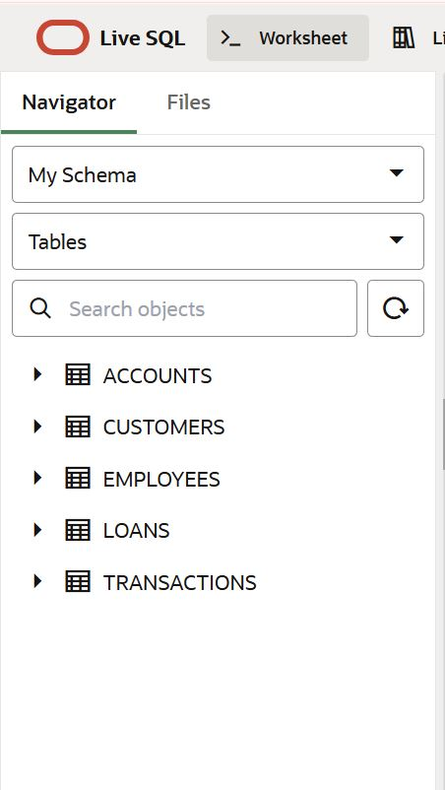

Account table:  
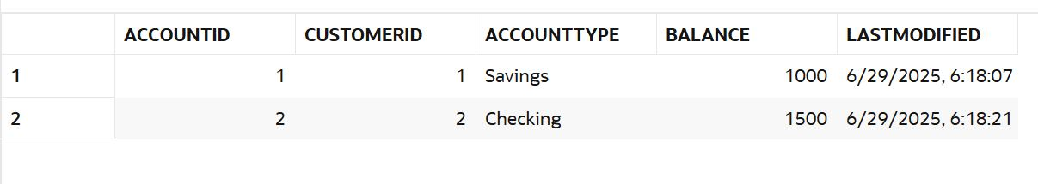

Customers table:

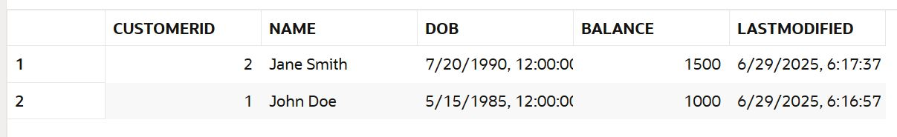

Employees table:

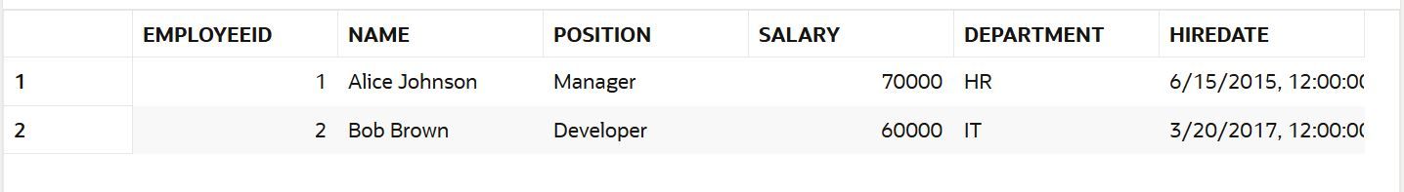

Loan table:



Transaction table:

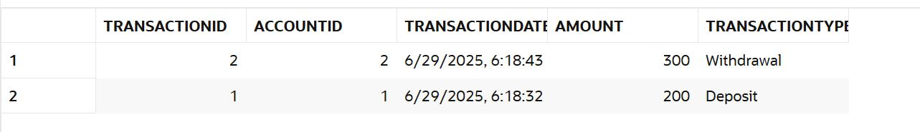

**Exercise 1: Control Structures**

**1)Write a PL/SQL block that loops through all customers, checks their age, and if they are above 60, apply a 1% discount to their current loan interest rates.**

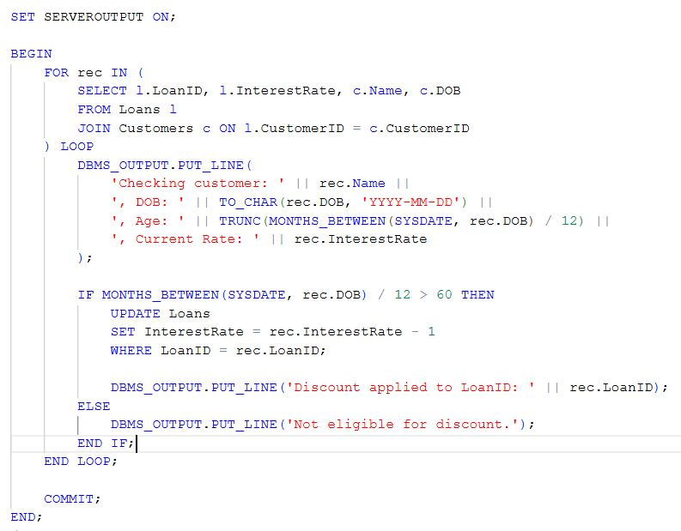

OUTPUT:

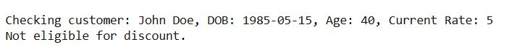

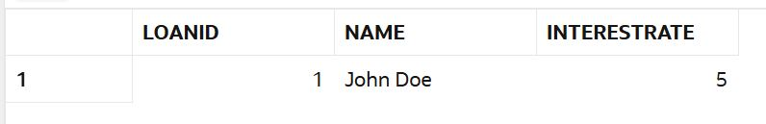

**2) Write a PL/SQL block that iterates through all customers and sets a flag IsVIP to TRUE for those with a balance over $10,000.**



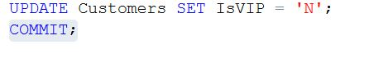

**PROGRAM:**

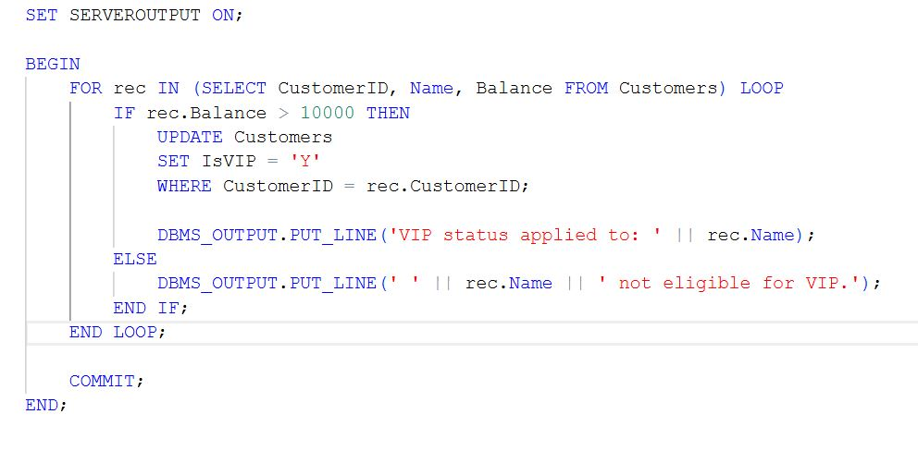

**OUTPUT:**

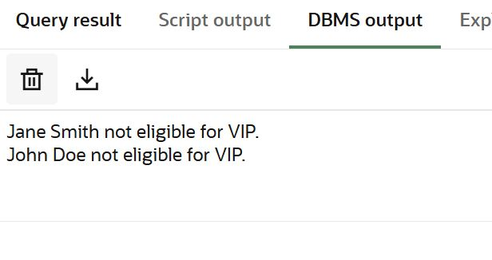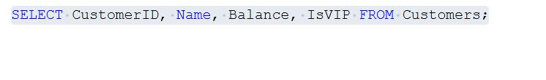

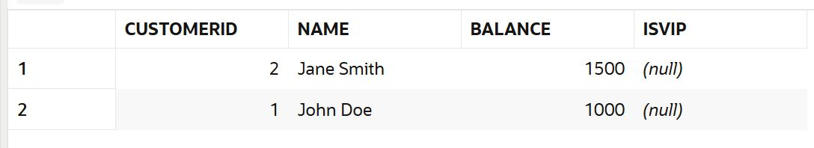

**3) Write a PL/SQL block that fetches all loans due in the next 30 days and prints a reminder message for each customer.**

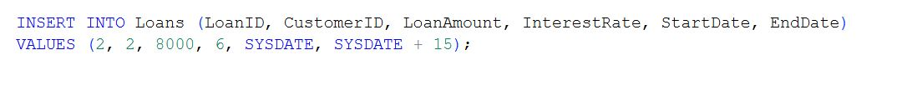

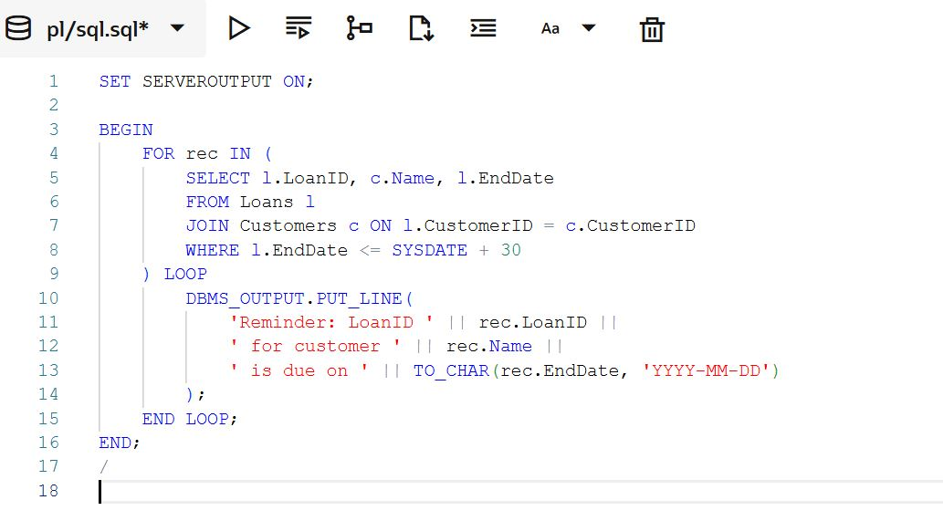

**OUTPUT:**

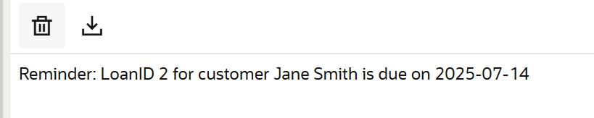

**Exercise 2: Error Handling**

**1) Write a stored procedure SafeTransferFunds that transfers funds between two accounts. Ensure that if any error occurs (e.g., insufficient funds), an appropriate error message is logged and the transaction is rolled back.**

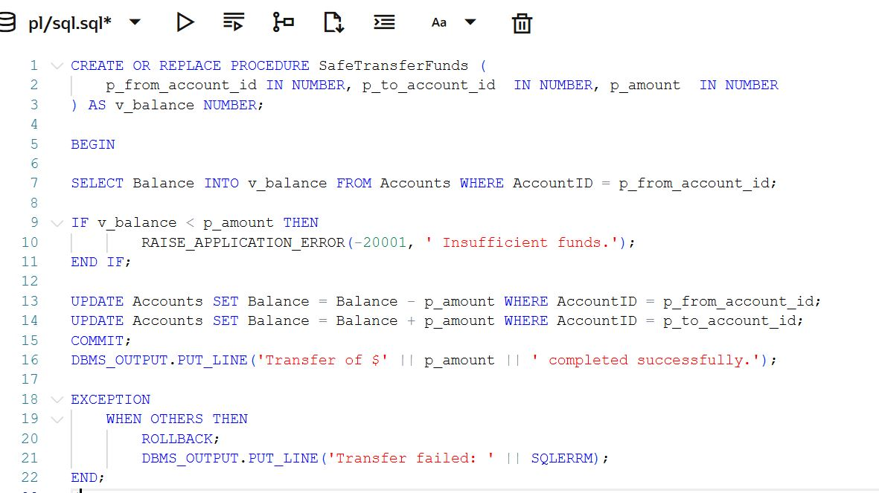

**INPUT 1:**

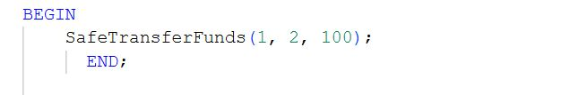

**OUTPUT 1:**

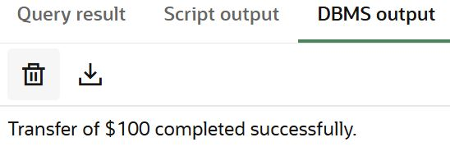

**INPUT 2:**

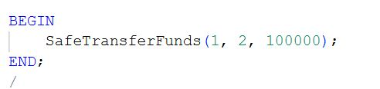

**OUTPUT 2:**

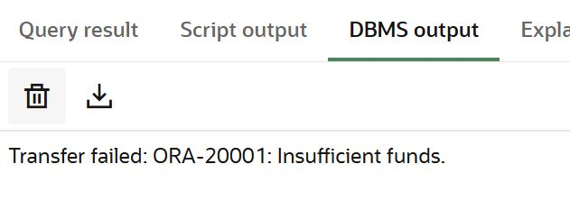

**VERIFY:**

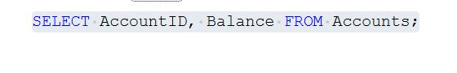

**OUTPUT TABLE :**

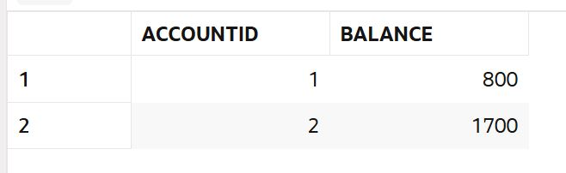

**2)** **Write a stored procedure UpdateSalary that increases the salary of an employee by a given percentage. If the employee ID does not exist, handle the exception and log an error message.**

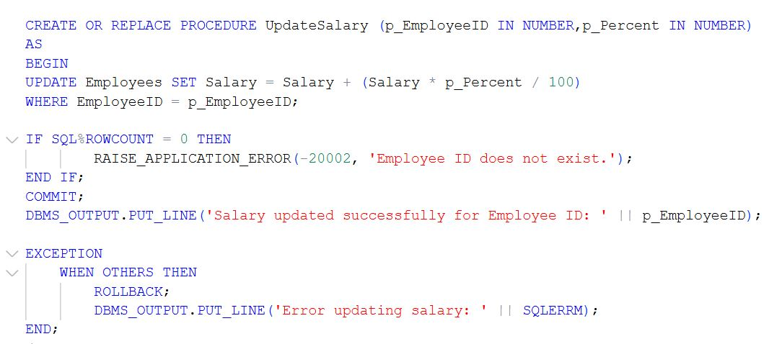



Insert into table employee :



Verify:

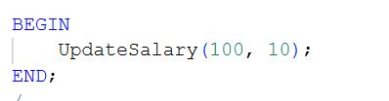

Output:

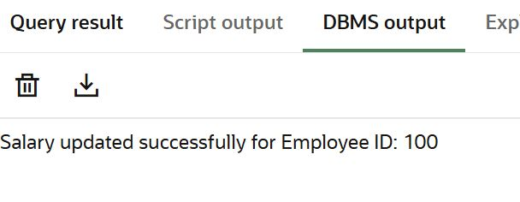



**OUTPUT:**

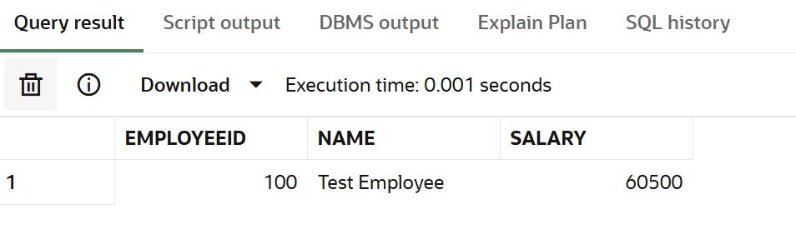

**3)** **Write a stored procedure AddNewCustomer that inserts a new customer into the Customers table. If a customer with the same ID already exists, handle the exception by logging an error and preventing the insertion.**

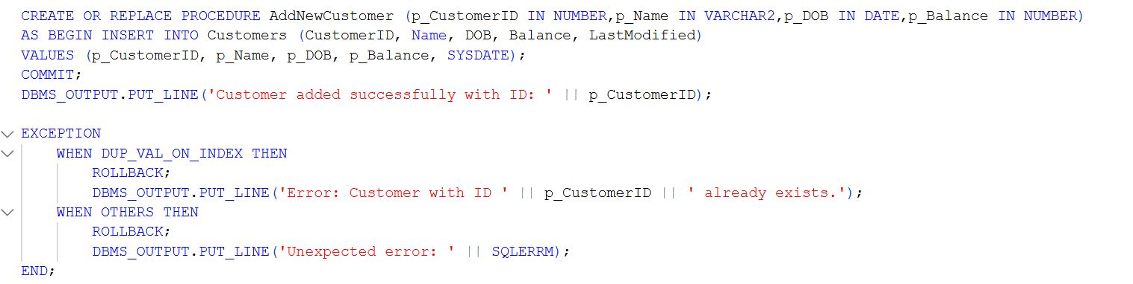



**VERIFY:**

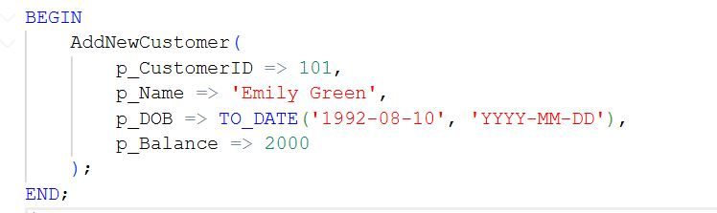

**OUTPUT:**

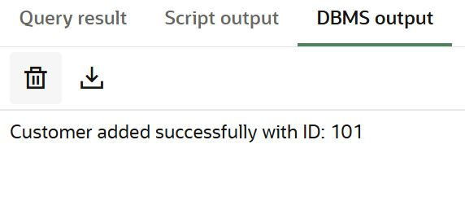

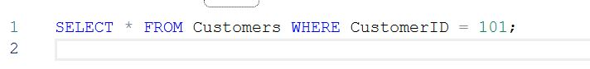

**OUTPUT:**



**Exercise 3: Stored Procedures**

**1) Write a stored procedure ProcessMonthlyInterest that calculates and updates the balance of all savings accounts by applying an interest rate of 1% to the current balance.**

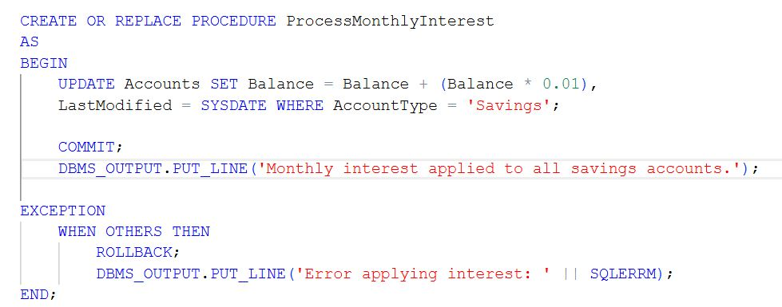

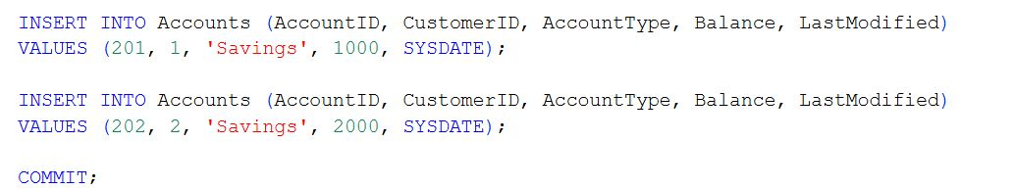

**VERIFY:**

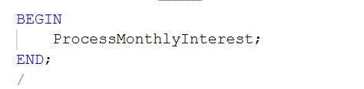

**OUTPUT:**

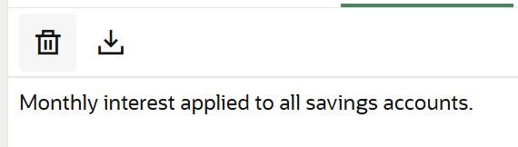

**OUTPUT:**

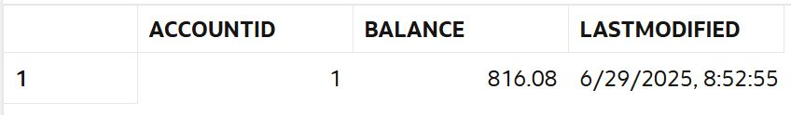

**2)** **Write a stored procedure UpdateEmployeeBonus that updates the salary of employees in a given department by adding a bonus percentage passed as a parameter.**

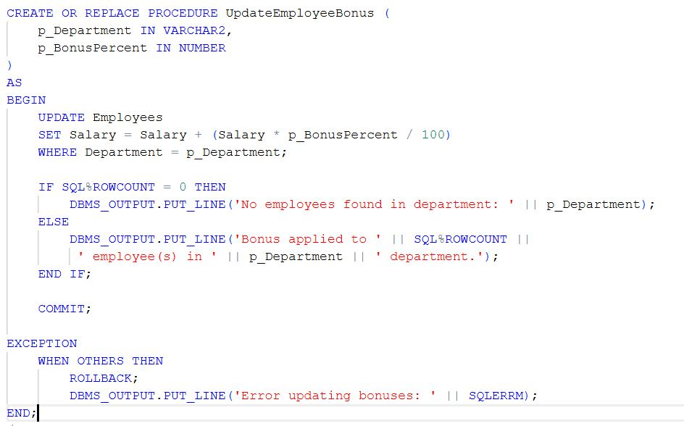

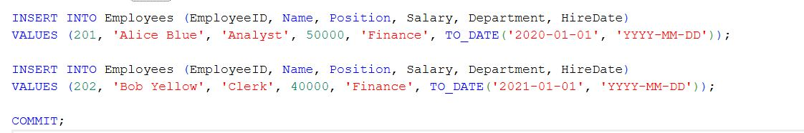

**VERIFY:**

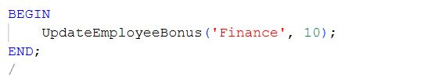

**OUTPUT:**

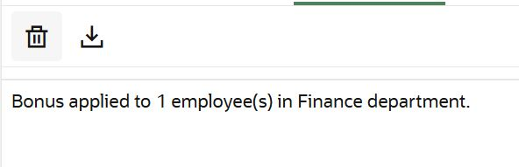

**OUTPUT:**

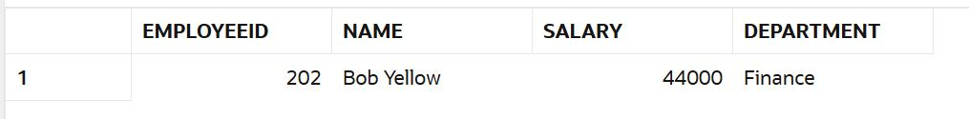

**3)** **Write a stored procedure TransferFunds that transfers a specified amount from one account to another, checking that the source account has sufficient balance before making the transfer.**

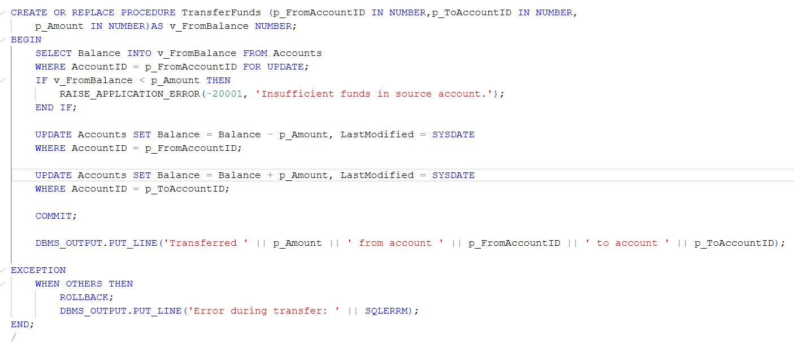

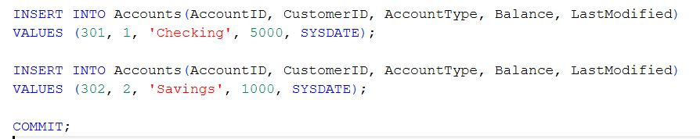

**VERIFY:  
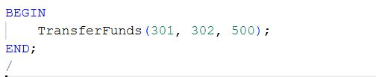**

**OUTPUT:**

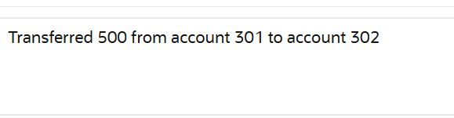

**Exercise 4: Functions**

**1) Write a function CalculateAge that takes a customer's date of birth as input and returns their age in years.**

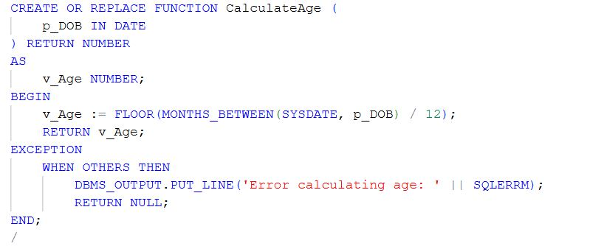

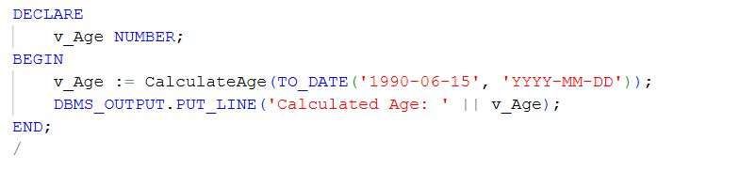

**OUTPUT:**

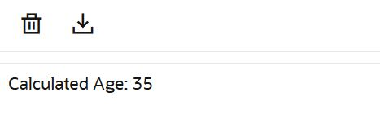

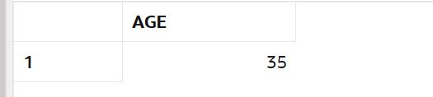

**2)** **Write a function CalculateMonthlyInstallment that takes the loan amount, interest rate, and loan duration in years as input and returns the monthly installment amount.**

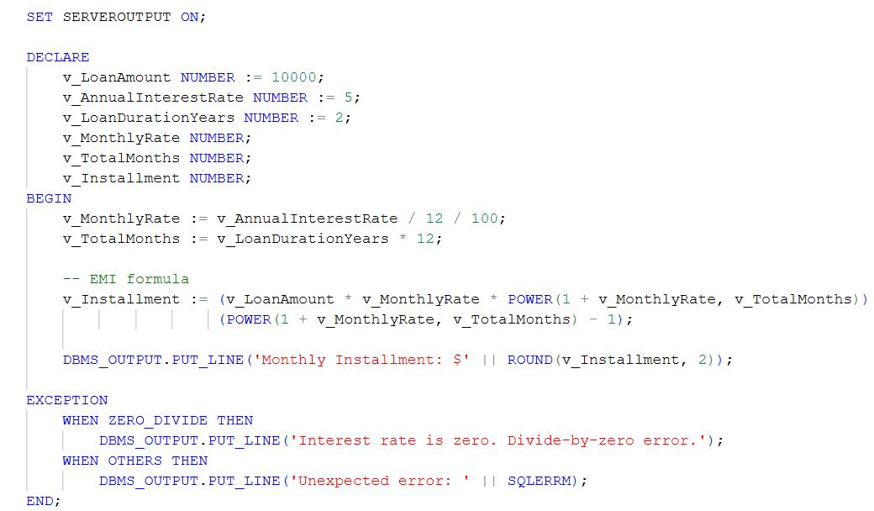

**OUTPUT:**

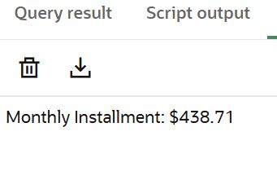

**3)** **Write a function HasSufficientBalance that takes an account ID and an amount as input and returns a boolean indicating whether the account has at least the specified amount.**

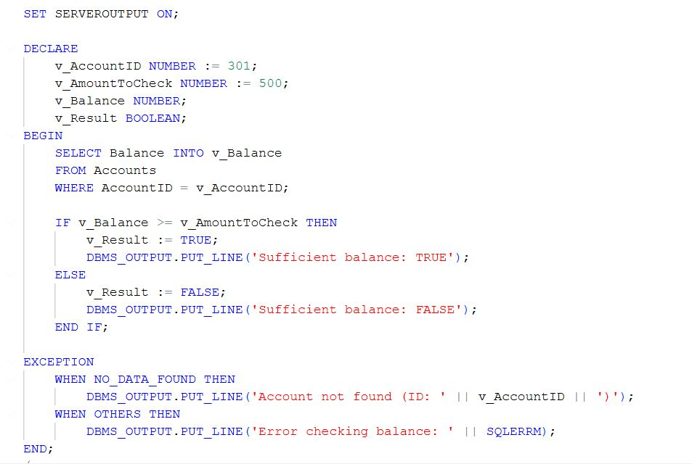

**OUTPUT:**

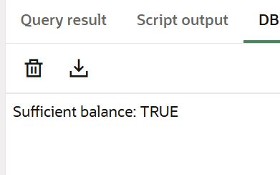

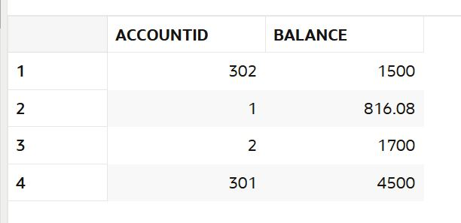

**Exercise 5: Triggers**

**1) Write a trigger UpdateCustomerLastModified that updates the LastModified column of the Customers table to the current date whenever a customer's record is updated.**

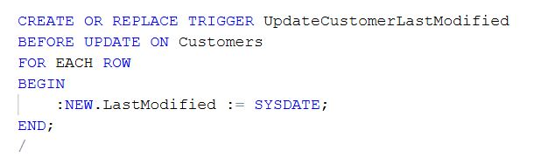

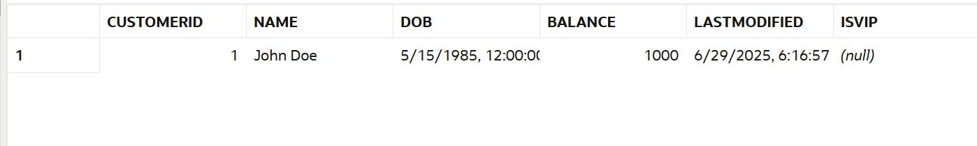

**2)** **Maintain an audit log for all transactions.**

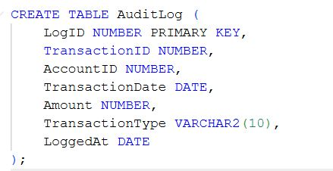

**TRIGGER:**

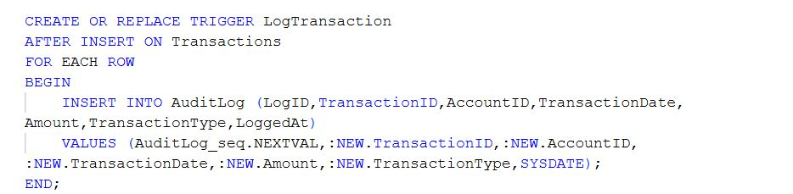





**OUTPUT:**



**3)** **Enforce business rules on deposits and withdrawals**

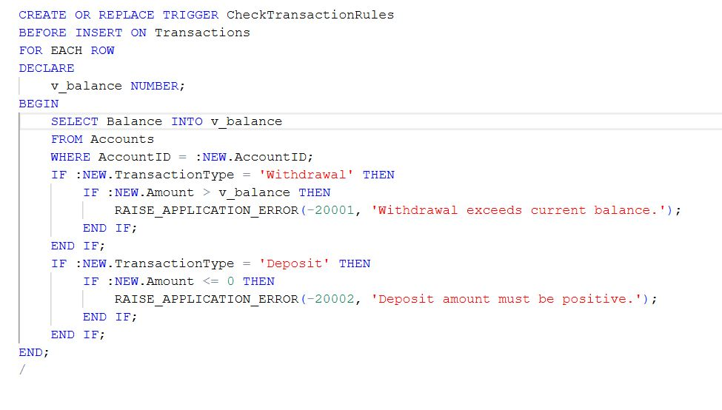

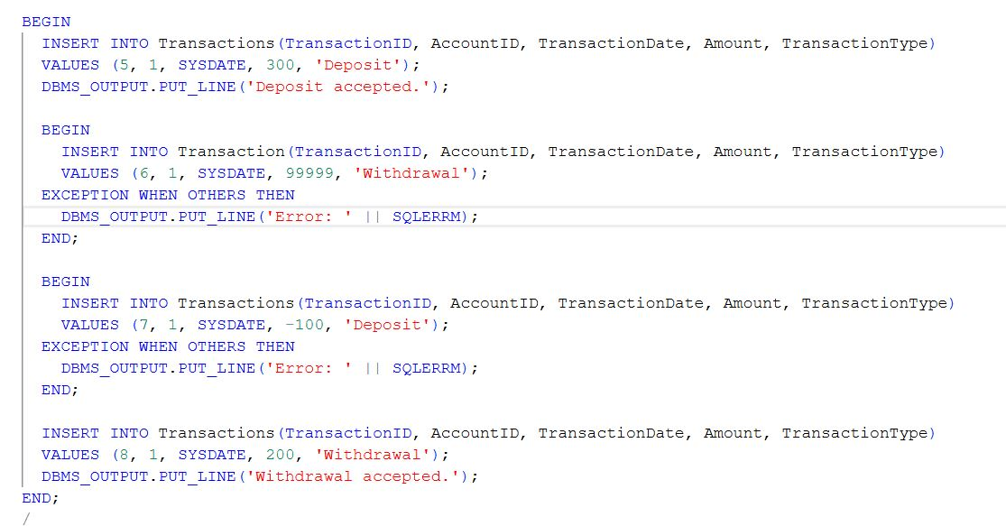

**OUTPUT:**

Deposit accepted.

Error: ORA-20001: Withdrawal exceeds current balance.

Error: ORA-20002: Deposit amount must be positive.

Withdrawal accepted.

**Exercise 6: Cursors**

**1)**Generate monthly statements for all customers.

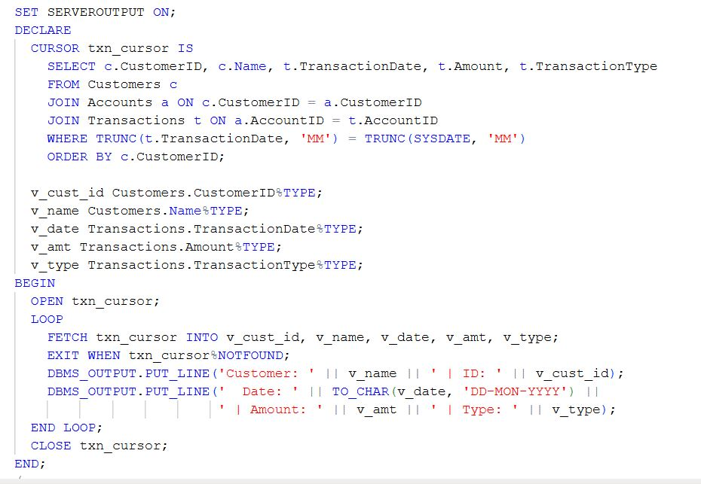

OUTPUT:

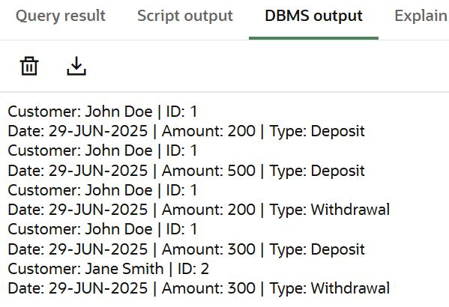

**2:** Apply annual fee to all accounts.

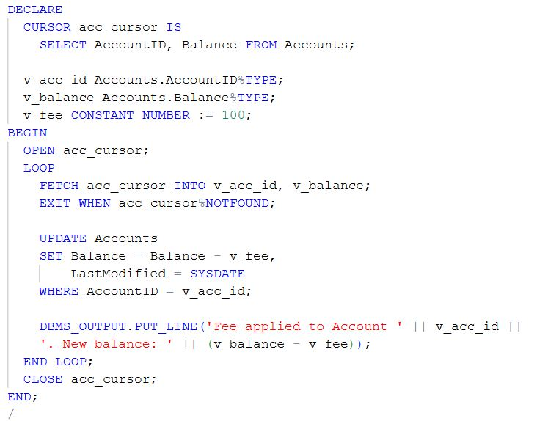

OUTPUT:

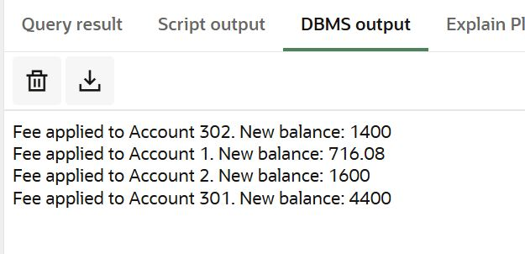

**3:** Update the interest rate for all loans based on a new policy.

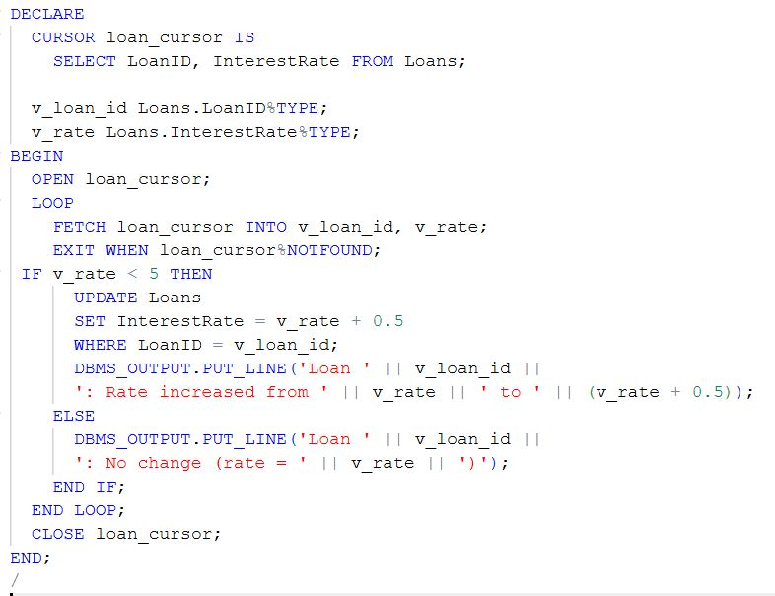

OUTPUT:

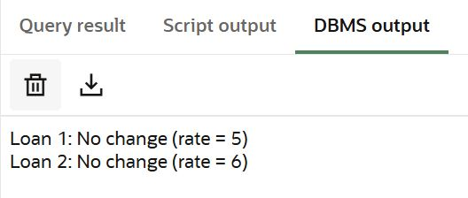

**Exercise 7: Packages**

**1:** Group all customer-related procedures and functions into a package.

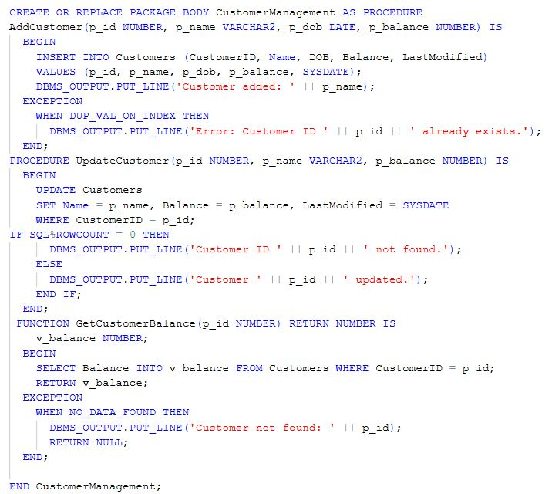

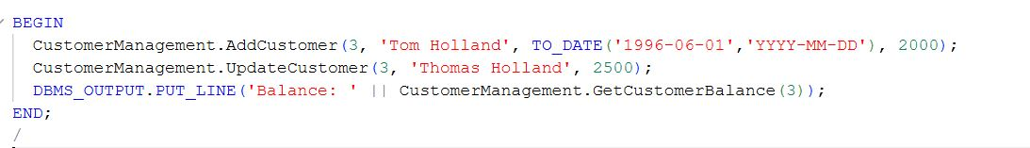

OUTPUT:

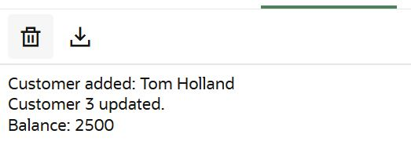

**2:** Create a package to manage employee data.

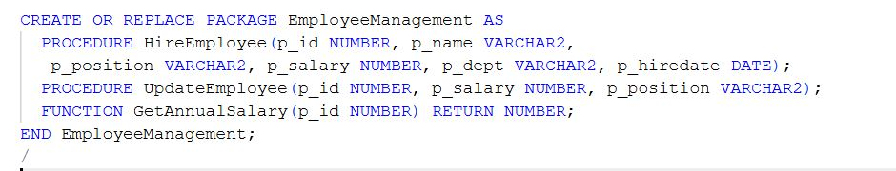

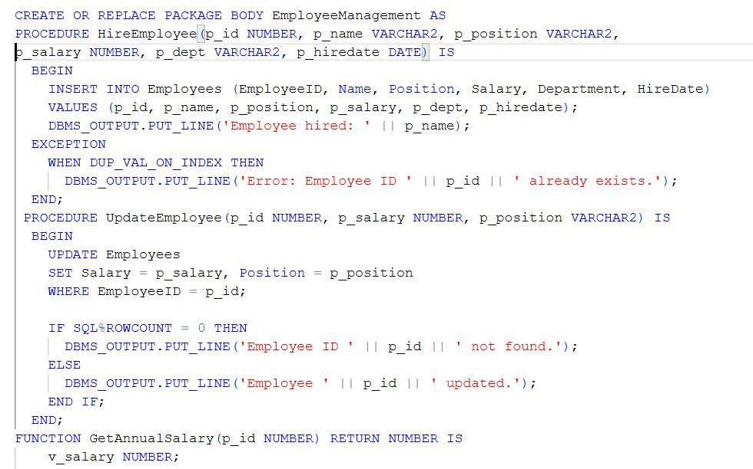

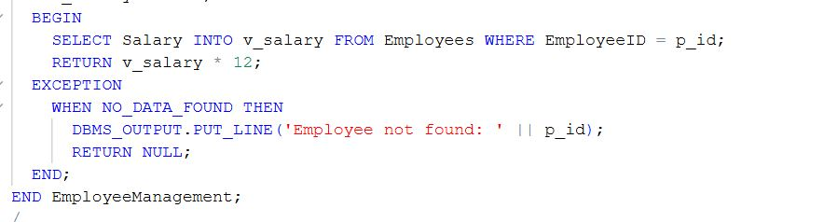

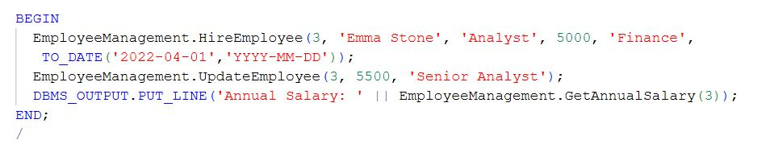

OUTPUT:  
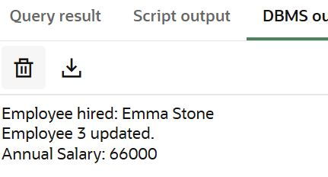

**3:** Group all account-related operations into a package.



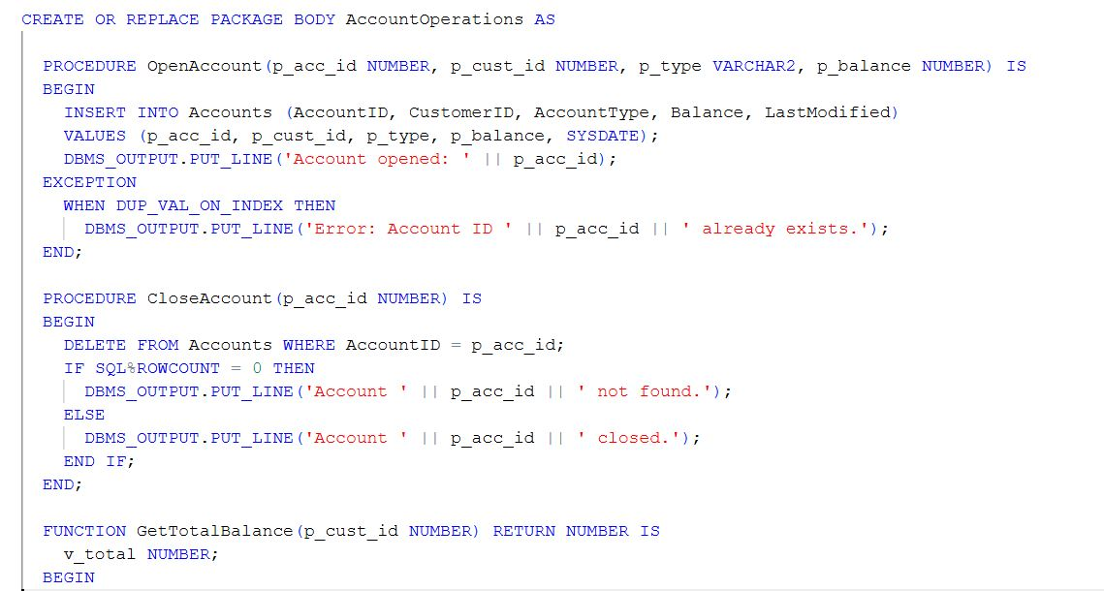

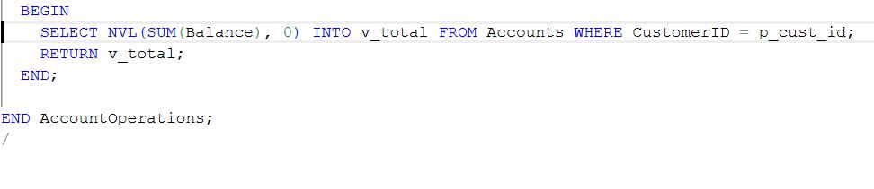

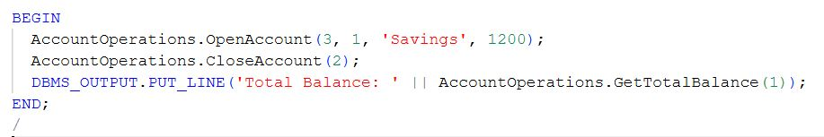

OUTPUT:

